FIU Foundation, Inc.
Budget Manual
FY 2023-24

A document to guide and assist finance managers in the annual forecast and budget process.

TABLE OF CONTENTS
Overview 3
Original Budget 4
Overview 4
Viewing Original Budget in PantherSoft 4
The Forecast 7
Overview 7
Responsible Parties: All Units 7
Accessing the ACTUAL Ledger 8
Entering the Forecast in the ACTUAL Ledger 10
Using the Calculator Tool 12
Adding Project IDs in the Budget Tool 14
The Budget 16
Overview 16
Funds 16
Accounts 17
To budget reimbursements to FIU 17
To budget all other expenses: 17
Sources of Revenue 17
Using Endowment Earnings Distributions for Budgeting Expenses 18
Budgeting at Detailed Account Level 18
Office of the President 18
External Relations 19
University Advancement 19
Foundation Business Office 19
Permanent Salaries & Benefits Budget Accounts 21
Temporary Employee Budget Accounts 22
Other Operating Expense Budget Accounts 24
Entering the Budget in PantherSoft 28
Accessing the REQUESTED Ledger 28
Entering the Budget in REQUESTED Ledger 29
The DSO Reimbursements Tool 32
Creating a DSO Reimbursement 32
Modifying DSO Reimbursements 35
Running Budget Reports 36
FIU02_Budget_Data Query 36
FIU02_Budget_BX_By_Project nVision Report 37
Running Reports After Allocation for 3% Gift Fee Runs 40
Deadlines 40
Post-Budget Accountability 41
Appendix – Looking Up Budgetary Accounts 42
Looking Up Budgetary Accounts Using Tree Viewer 42
Looking Up Budgetary Accounts Using Query Viewer 45

Overview
This budget manual will provide you with information and guidelines on how to calculate your FIU02 FY 2022-23 Forecast, build your FY 2023-24 Budget, and enter both into PantherSoft.
You will be required to forecast the last four months of FY 2022-23 (March 1, 2023– June 30, 2023) and budget all 12 months of FY 2023-24 (July 1, 2023 – June 30, 2024). Please provide both projections on a cash basis.
The budget submission process includes budgeting by line item through PantherSoft Financials. This line-item detail will help you throughout the year in coding actual monthly revenues and expenditures and understanding operating performance. This in turn will facilitate the decision-making process and assist with variance analysis and reporting.
The following table summarizes the forecast and budget process:
FY 2022-23 Forecast (Actual Ledger)
Time period | Initial Data Source | Action Required by  Budget Manager | Goal
07/01/2022  to  02/28/2023 | Actual amounts in the PantherSoft system for  7/1/2022 – 2/28/2023 | No action required | Project FY 2022-23 revenues and expenses using current year actuals
03/01/2023  to  06/30/2023 | Cash installments due between 3/1/2023 – 6/30/2023 for existing pledges in Raiser’s Edge as of 1/31/2023 have been pre-populated | Enter projections based on knowledge of revenues and expenses expected over the next 4-month period | Project final revenues and expenses for each project through June 30, 2023

FY 2023-24 Budget (Requested Ledger)
Time period | Initial Data Source | Action Required by  Budget Manager | Goal
07/01/2023  to  06/30/2024 | Cash installments due between 7/1/2023 – 6/30/2024 for existing pledges in Raiser’s Edge as of 1/31/2023 have been pre-populated | Input expected revenues and expenses for FY 2023-24 | Create a monthly line-item budget that reflects the departments’ anticipated activities for FY 2023-24

Original Budget

Overview
Original Budget is the Budget Base or current year’s entire annual budget. It is available to you as a reference when forecasting the financial activity of your unit for the remainder of the current fiscal year.
Note: The original budget is view only; you cannot change the original budget data in PantherSoft. The Original Budget is recorded in the ledger DEPTBUD.

Viewing Original Budget in PantherSoft
- Login in to PantherSoft Financials and navigate to the Detail Budget Maintenance (DBM) using the drop-down menu.
- Select Budget Development
- Click on Budget Tools Icon
- Choose Detail Budget Maintenance
- In the Business Unit enter FIU02 for FIU Foundation
- Click the magnifying glass button next to the Ledger field to open the Look Up Ledger box. Select ledger DEPTBUD. The lookup window will close.
- Click the Search button
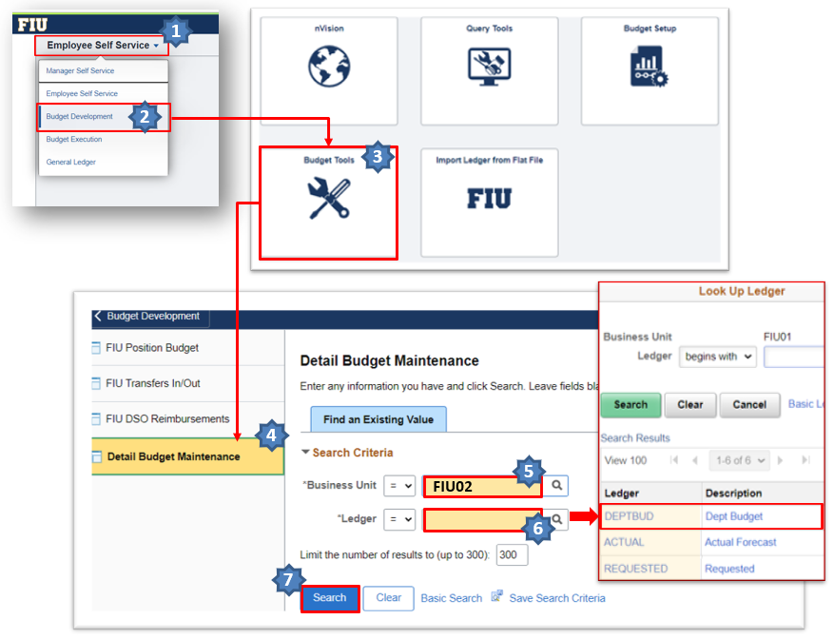
- On the following screen:
  - Enter 2023 in the Fiscal Year field; and
  - Click “View All” to display all the criteria
  - Type the Project ID in the Project field.
For a complete listing of the Foundation’s (FIU02) Project IDs, please run the following query: FIU02_PROJECT_INFO2.
  - Click the “Query” link to proceed to the following screen.
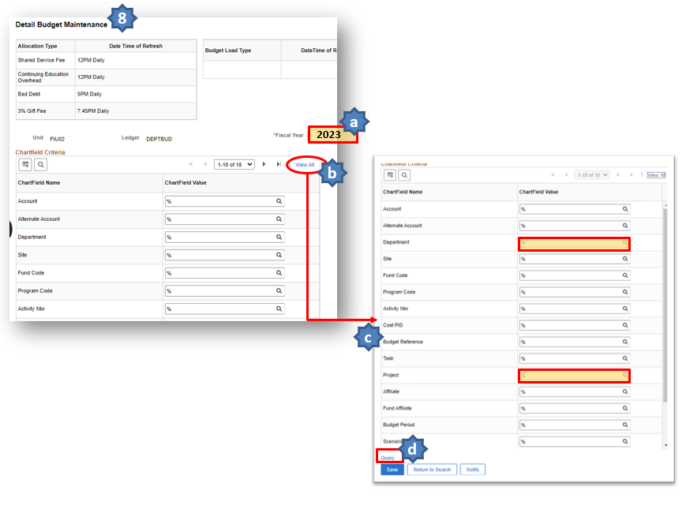
- On the new screen, “Data By Year”, the numbers will be blank until you click the Calculate button.
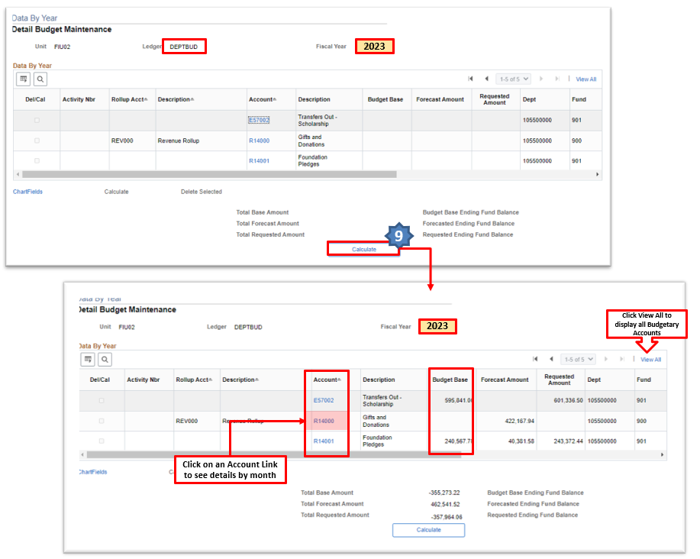

The Forecast

Overview
The forecast is your best estimate of your unit’s financial performance through the end of the current fiscal year. The forecast for FY 2022-23 is comprised of 8 months of actuals (July 2022 to February 2023) pre-populated for you in PantherSoft and 4 months of projections (March 2023 to June 2023) that you will be required to enter. Expected pledge payments (cash installments) due between March 2023 and June 2023 for existing pledges in Raiser’s Edge as of 1/31/2023 will also be pre-populated for you in PantherSoft using budget account R14001. Although these amounts will not be grayed out in DBM, they will be view only and therefore cannot be changed. Budget managers must still enter cash installments on gifts expected to be received over the last 4 periods of the current fiscal year that are either new or not tied to a signed pledge/ gift agreement as of 1/31/2023.

Responsible Parties: All Units
- Budget managers are responsible for forecasting endowed revenues (gifts to corpus only), non-endowed revenues and expenses in the ACTUAL ledger for FIU02 for each project – including ones without an original budget – for the remaining 4 months of the current fiscal year (FY 2022-23).

- The forecast should be comprised of the revenues and expenses you really anticipate collecting over the next 4 months, not simply the difference between your original budget and year-to-date actuals.

- Forecasted expenses for periods 9 – 12 must be less than or equal to the February 28th ending spendable balance plus forecasted non-endowed revenues, net of the 3% gift fee where applicable, for periods 9 – 12 for each project.

Accessing the ACTUAL Ledger
- Login in to PantherSoft Financials and navigate to the Detail Budget Maintenance (DBM) using the drop-down menu. Select Budget Development and click on Budget Tools Icon. Choose Detail Budget Maintenance.
- In the Business Unit enter FIU02 for FIU Foundation, and then click the magnifying glass button next to the Ledger field to open the Look Up Ledger box.
- Select ledger ACTUAL. The lookup window will close.
- Click the Search button.
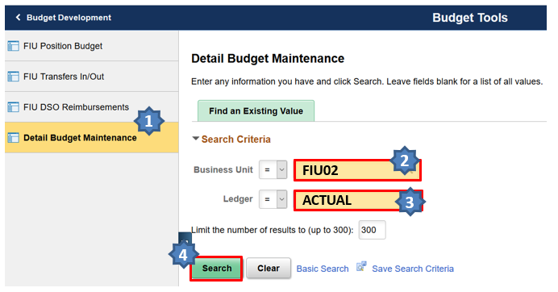
- On the following screen enter Fiscal Year = 2023 and the Department ID and/or Project ID. To see the Project ID field, you may have to click the View All link. Click the Query link to proceed to the following screen.
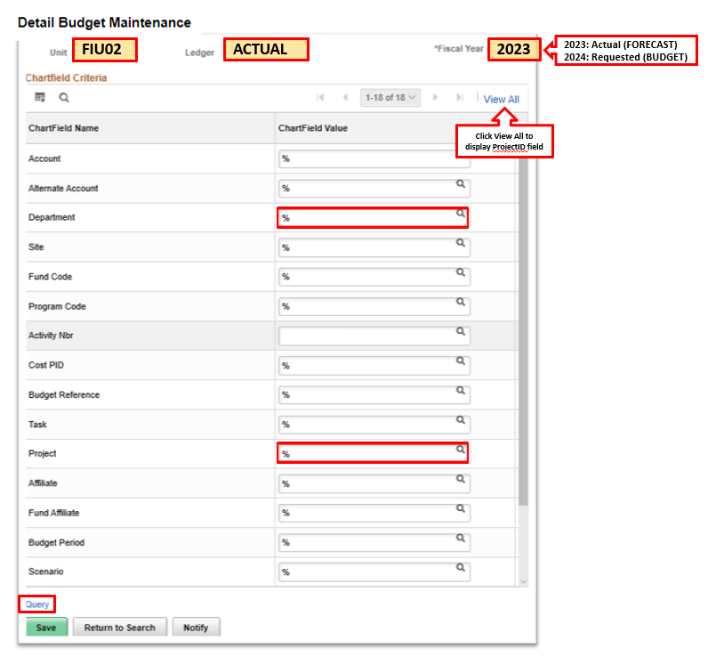
- The numbers on the screen below will be blank until you click the Calculate button.
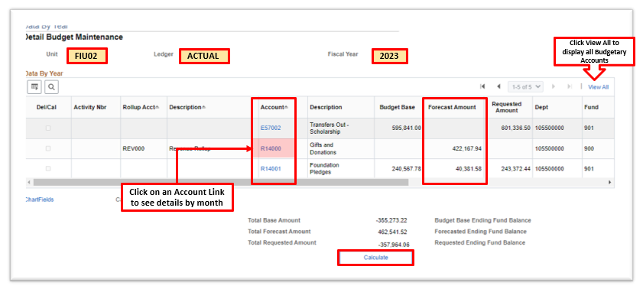

Entering the Forecast in the ACTUAL Ledger
- Click the hyperlink for the revenue or expense account of the project that you would like to update.
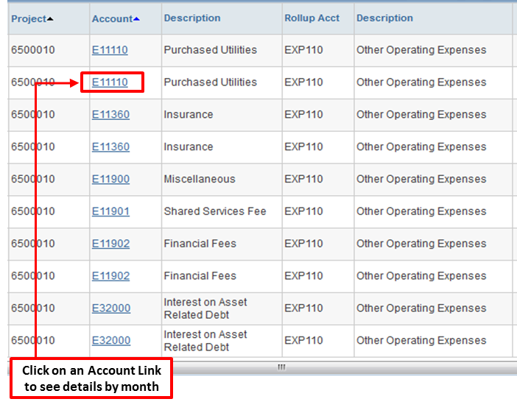
The Detail Budget Maintenance (DBM) page shows each of the first 8 months of the current fiscal year in which there was activity as view only since these are actuals and therefore cannot be changed. It also shows expected pledge payments (cash installments) due between periods 9 and 12 for existing pledges in Raiser’s Edge as of 1/31/2023. These cash installments were pre-populated for you in PantherSoft using budget account R14001, which is specific to pre-populated pledge payments, and are also view only.
You will have the ability to enter the forecasted revenue and expense amounts for each project for the remaining months of the fiscal year, Period 9 (March 2023) through Period 12 (June 2023).
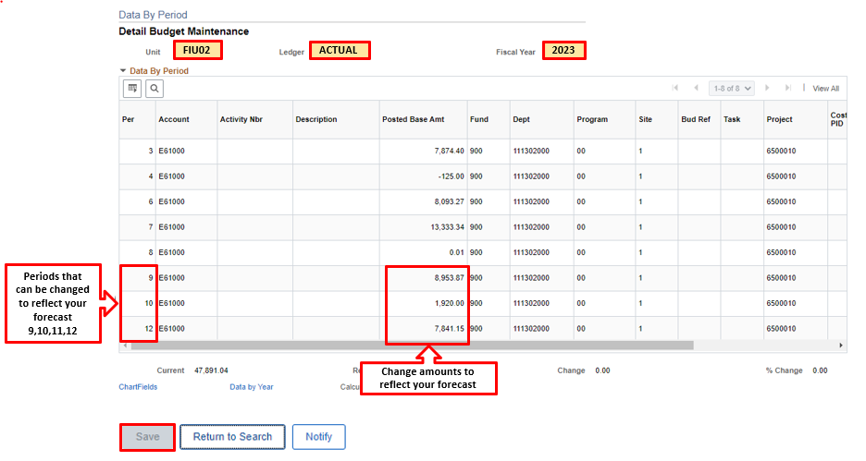
- Scroll to the right and Click the plus sign “+”in order to add lines for the remaining periods.
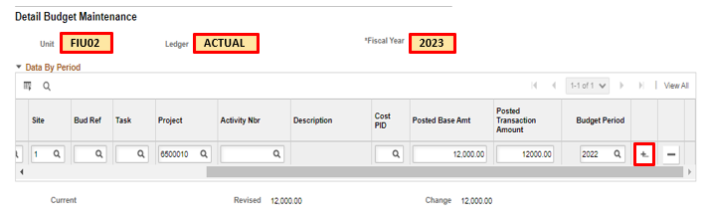
- Type in the number of rows you would like to add, then click OK button.
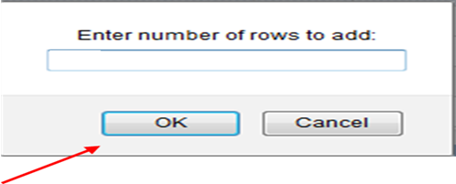
- Once all changes have been made to this account, click on the Save button to go back to the main page and continue with your forecast for another account.

Using the Calculator Tool
At the bottom of the Data By Period page is the Calculator link (this is not the same as the Calculate button).
The calculator is a shortcut for entering forecasted numbers for many periods. It is very useful for various calculation types.
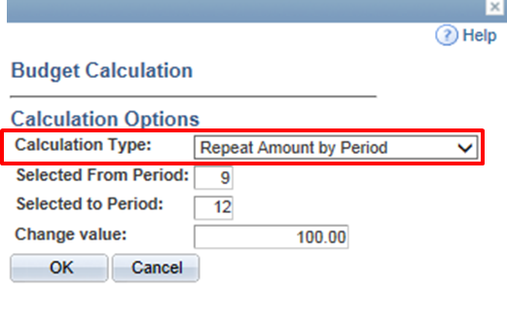
• Add by Period: This option allows an amount to be entered in the Change Value field and adds this amount to the specified month(s). e.g. If March – June has an existing value of $200 and the change value entered is $100, the system allocates $300 per month.
• Adjust by Percent: This option allows an amount to be entered in the Change Value field and adjusts the amounts by a user defined percentage. e.g. If March – June each has a value of $200 and a change value of 5% is selected, the system allocates $210 per month. Type 5 in the calculator if a 5% increase is needed OR -5 if a decrease of 5% is required.
• Repeat Amount by Period: This option allows an amount to be entered in the Change Value field and repeats the amount for the remaining months. e.g. If March – June each has a value of $200 and you set the change value to $100, the system allocates $100 per month.
• Spread Evenly by End of Qtr: spreads the amount entered in the Change Value evenly across periods 3, 6, 9 and 12 regardless of value entered in Selected From Period and Selected to Period fields; e.g. $1,200 Spread Evenly by End of Qtr allocates $300 in periods 3, 6, 9 and 12.
• Spread Evenly by Beginning of Qtr: spreads the amount entered in the Change Value evenly across periods 1, 4, 7 and 10 regardless of value entered in Selected From Period and Selected to Period fields; e.g. $1,200 spread evenly by Beginning of Quarter allocates $300 in periods 1, 4, 7 and 10.
• Spread Evenly by Period: This option allows an amount to be entered in the Change Value field and spreads this amount evenly over the remaining months. e.g. $200 spread evenly over 4 months allocates $50 per month.
Once you have made your changes using the Calculator, click the OK button to see your changes reflected monthly.

Adding Project IDs in the Budget Tool
Project IDs created after January 31, 2023 and/or Project IDs without revenue or expense transactions during the first 8 months of FY 2022-23 must be added to the budget tool. Please do not add new project ID’s for new gifts for which a project that does not yet exist (refer to the Budgeting at Detailed Account Level section, page 18).
To add a new project ID,
- Login in to PantherSoft Financials and navigate to the Detail Budget Maintenance (DBM) using the drop-down menu. Select Budget Development and click on Budget Tools Icon. Choose Detail Budget Maintenance.
- Access the ACTUAL or REQUESTED ledger and enter an existing Project ID. Click the Query link to proceed to the following screen.
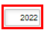
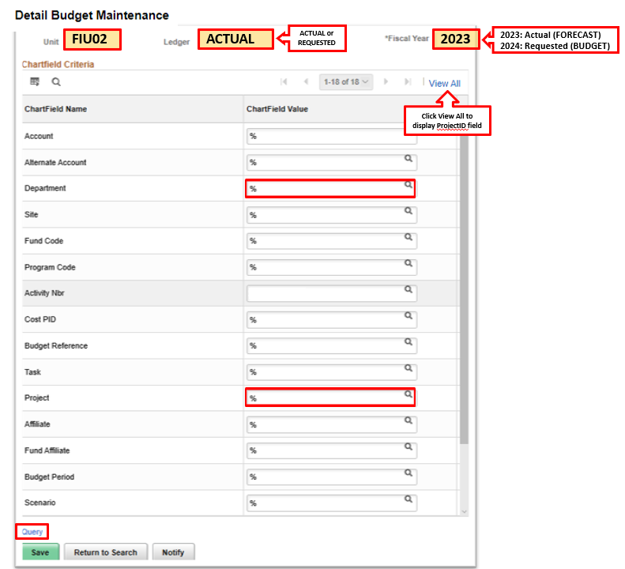
- Click any Account link to proceed to the next screen.
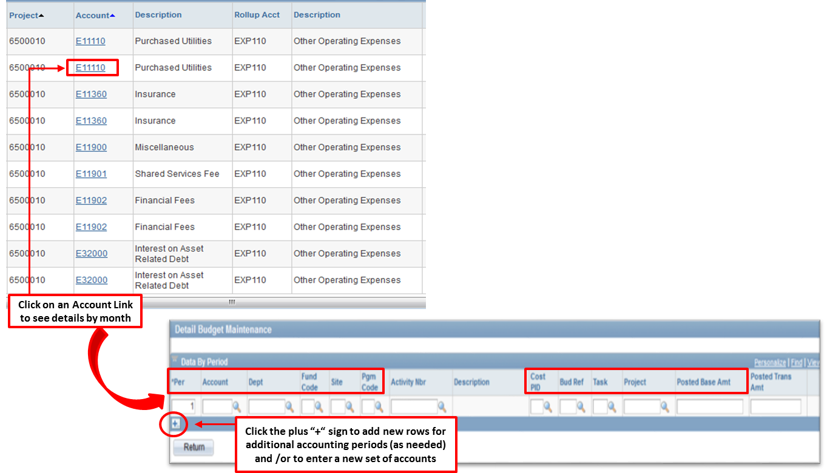
Fill in only the following cells:
- Per (change the number to reflect the period for which you are forecasting)
- Account
- Dept
- Fund Code (900 or 903) – (refer to information about funds, page 16)
- Site (always choose 1 in Actual Ledger for Forecast and 01 in Requested Ledger for Budget)
- Pgm Code (should always be 00)
- Project
- Posted Base Amount
IMPORTANT: Do not enter data into the Activity Nbr, Bud Ref or Task cells.
For a complete listing of the Foundation’s (FIU02) Project IDs, please run the following query: FIU02_PROJECT_INFO2
Once all forecast lines have been added, click the Data by Year link and Save your changes in PantherSoft.

The Budget

Overview
The budget for FY 2023-24 is comprised of 12 months of revenue and expense projections from July 2022 to June 2023. Expected pledge payments (cash installments) due during that period for existing pledges in Raiser’s Edge as of 1/31/2023 will also be pre-populated for you in PantherSoft using budget account R14001, which is specific to pre-populated pledge payments. Although these amounts will not be grayed out in DBM, they will be view only and therefore cannot be changed. Budget managers must still enter cash installments on gifts expected to be received over next fiscal year that are either new or not tied to a signed pledge/ gift agreement as of 1/31/23.
- Budget managers are responsible for entering a 12-month budget for endowed revenues (gifts to corpus only), non-endowed revenues and expenses in the REQUESTED ledger for FIU02 for each project in their area, including projects that do not yet exist but are expected between now and June 30, 2024.
- Please refrain from using the straight-line method in budgeting revenues and expenses.
- Please keep in mind that historical revenues and expenses are not necessarily an indication of future revenues and expenses.
- Revenue budgets are jointly developed by Deans and the Senior Vice President of University Advancement with input from unit Development Officers. Expense budgets should be compiled by budget managers with guidance from their unit’s leadership.
- Budget managers must ensure that FY 2023-24 budgeted expenses are less than or equal to forecasted ending spendable balance on June 30, 2023 (including endowment distributions) plus budgeted non-endowed revenues for FY 2023-24, net of the 3% gift fee where applicable, for each project.
- Building Funds budgets are entered into PantherSoft by the Foundation based on assumptions developed in collaboration with each unit and Facilities Management. Unit budget managers are required to communicate expected new Building Fund gifts and planned transfers to the University for construction to the Foundation Business Office for inclusion in the budget.

Funds
Budget project revenues and expenses using the following fund codes:
- Use Fund 900 for non-endowed revenues
- Use Fund 903 for endowed revenues
- Use Fund 900 for ALL expenses regardless of unit or expense type

Accounts
Use budgetary account R14000 to forecast and budget revenues.
Use the following budgetary accounts to forecast and budget expenses:

To budget reimbursements to FIU

- E57000 – All Other Expenses
- E57001 – Equipment Expenses
- E57002 – Scholarship Expenses
- E57003 – Construction Expenses
- E57004 – Salary Expenses
- E57006 – Events
- E57007 – Subscriptions and Memberships
- E57008 – Postage
- E57009 – Travel
- E57010 – Insurance
- E57011 – Rental
- E57012 – Repairs & Maintenance
- E57013 – Professional Services
- E57014 – Advertising and Promotion
- E57015 – Materials & Supplies

To budget all other expenses:
Use the University Budgetary Accounts. Budget managers need to budget expenses using the University’s detailed budgetary accounts (refer to the Appendix - Budgetary Accounts page 42).

Sources of Revenue
There are three possible sources of revenue:
- Cash installments (pledge payments) on existing gifts:
- Expected pledge payments in FY 2023-24 for existing pledges in Raiser’s Edge as of 1/31/2023 will also be pre-populated for you in PantherSoft using budget account R14001, which is specific to pre-populated pledge payments. Although these amounts will not be grayed out in DBM, they will be view only and therefore cannot be changed.
- Any past due pledge payments anticipated to be collected next fiscal year. These will not be pre-populated thus require entry into the budget tool if expected.
- Expected contributions not tied to a signed pledge/ gift agreement such as outright discretionary gift, board dues, etc.
- Cash installments on expected NEW GIFTS (those for which a gift agreement has not yet been established) as of January 31, 2023. This data will be compiled and reviewed by the Foundation’s CEO to ensure alignment with the Capital Campaign goals. Final revenue projections for NEW gifts will be returned to the unit budget managers for entry in the budget tool. New gift revenue budgets should be consistent with goals included in Advancement’s fund-raising matrix and the overall goals and direction of the $750 million Capital Campaign.
New Gifts will not have their own Project IDs until agreements have been signed. Until they do, budget revenues and expenses for new projects in the last Project ID of your unit which begins with the first 2 digits associated with your unit followed by “99999” (e.g. Athletics’ Project ID 4099999). It is important that the budget manager keep a detailed record of all the budgeted revenues and expenses “lumped” together under this project for future variance reporting.

Using Endowment Earnings Distributions for Budgeting Expenses
All Foundation funds, including endowed funds, are pooled together for investment purposes. At the end of each quarter, each endowment receives its pro-rated share of the Foundation’s investment earnings, including interest income and realized/unrealized gains and losses. At fiscal year-end (June 30th), the Foundation’s Board of Directors determines what percentage – if any – of the endowment’s annual earnings (credited to the reserve in fund 902 each quarter) will be available for spending and determine the administrative fee to be charged to endowments.
In early April, the Foundation Business Office will provide each unit with the endowment earnings distribution amounts anticipated to be made on June 30th. These figures will be final unless there is a significant downturn in the market, at which point you will be immediately advised of changes by the Foundation Business Office. The forecasted June 30, 2023 spendable balances (in funds 900 and 901) along with the spending distribution provided in this scenario should be considered when budgeting expenses related to the corresponding endowment project for FY 2023-24. Please do NOT budget endowment earnings as revenue to your projects.

Budgeting at Detailed Account Level
All scholarship expenses are to be budgeted using detail budget account E57002 instead of expense roll-up account E11900. Scholarship expenses budgeted in the Foundation (FIU02) should equal scholarship expenses budgeted on the university side (FIU01).

Office of the President
Project Name | Project ID | Description | Account | Fund
Presidential Compensation | 7020030 | Salary | E71999 | 900
Presidential Compensation | 7020030 | Benefits | E71950 | 900
Presidential Compensation | 7020030 | Car Allowance | E76100 | 900
Presidential Compensation | 7020030 | Performance Bonus | E71517 | 900
Philanthropic Cultivation | 7020031 | Miscellaneous | See Below | 900
President's Business Allowance | 7020032 | Miscellaneous | See Below | 900
President's Travel Allowance | 7020033 | Miscellaneous | See Below | 900

External Relations
Project Name | Project ID | Description | Account | Fund
Annual Fund | 7010000 | President’s Council Dues | R14005 | 900
President’s Council | 7010012 | Miscellaneous | See Below | 900
Lobbying | 7020016 | Miscellaneous | See Below | 900

University Advancement
Project Name | Project ID | Description | Account | Fund
Annual Fund | 7010000 | Unrestricted Annual Giving Revenues | R14002 | 900
Annual Fund | 7010000 | Foundation BOD Dues | R14004 | 900
Annual Giving Campaign | 7010011 | Miscellaneous | See Below | 900
Board of Directors | 7020011 | Miscellaneous | See Below | 900
Foundation Outreach Initiative | 7020012 | Salaries | E71999 | 900
Foundation Outreach Initiative | 7020012 | Non-Salaries | See Below | 900
Advancement General Support | 7021001 | Miscellaneous | See Below | 900
Administration & Operations | 7021002 | Miscellaneous | See Below | 900
Advancement Management | 7021003 | Miscellaneous | See Below | 900
Alumni Association | 7021004 | Miscellaneous | See Below | 900
Campaign Planning & Comm. | 7021005 | Miscellaneous | See Below | 900
Development Operations | 7021006 | Miscellaneous | See Below | 900
Donor Relations | 7021007 | Miscellaneous | See Below | 900
IGNITE Operations | 7021008 | Miscellaneous | See Below | 900

In addition to the Projects listed above, Advancement Operations also budgets revenues and expenses for university-wide projects.

Foundation Business Office
Project Name | Project ID | Description | Account | Fund
Foundation Operations | 7020010 | Salaries | E71999 | 900
Foundation Operations | 7020010 | Non-Salaries | See Below | 900
Foundation Operations | 7020010 | Audit | E72116 | 900
Foundation Operations | 7020010 | Insurance | E11360 | 900
NDMF Worker’s Compensation Fees | 7020013 | Miscellaneous | E11900 | 900
Advancement MARC Building Lease | 7020014 | Rental of Buildings | E11541 | 900
FBOG Assessment | 7020015 | Miscellaneous | See Below | 900
Foundation Marketing | 7020019 | Miscellaneous | See Below | 900
Institutional Memberships | 7020049 | Miscellaneous | See Below | 900
Financial Fees | 7029980 | Bank & Merchant Fees | E11902 | 900
Other Administrative Expenses | 7029990 | Miscellaneous | See Below | 900
General Reserve Expenses | 8000010 | Professional Services | E72000 | 900
General Reserve Expenses | 8000010 | All Other Expenses | See Below | 900
Investment Returns | 8000010 | Investment Income, Realized Gains and Losses, Unrealized Gains and Losses | E88000 | 900
Endowment Reserve | 8000011 | Miscellaneous | See Below | 900
Endowment Reserve | 8000011 | Investment Income, Realized Gains and Losses, Unrealized Gains and Losses | E88000 | 900
VP Allowances | Various | Miscellaneous | See Below | 900

Permanent Salaries & Benefits Budget Accounts
The following accounts are used to record salary expenses in the Detail Budget Maintenance (DBM) page. They correspond to the Employee Type (Faculty, Administrative or Staff).
E71121 | Faculty 12 Month Salaries
E71127 | Faculty 12 Month Salaries - COM
E71122 | Faculty 9 Month Salaries
E71123 | Faculty Summer A
E71124 | Faculty Summer B  All accounts listed include gross salaries
E71140 | Administrative Salaries
E71150 | Staff Salaries
E71153 | Salary Overtime  Includes overtime, on-call pay and law enforcement incentives.
E71999 | University-wide Salary Adjustments  This budgetary account includes an estimated amount for university-wide salary adjustments such as across-the-board salary increases and associated fringe benefits.
E71950 | Fringe Benefits  Under the Pooled Fringe Benefit Rate methodology there is only one benefits account for faculty, administrative and staff employees. Benefits amounts are automatically calculated and populated in the Position Budget as a percentage of salary based on University-Wide Pooled Fringe Benefit Rates below.  Starting in FY2023, new fringe benefit accounts by employee type were created to facility expenditure analysis.
E71961 | Fringe Benefits – Faculty
E71962 | Fringe Benefits – Admin
E71963 | Fringe Benefits – Staff
E71967 | Fringe Benefits – Faculty COM
E71969 | Fringe Benefits – Faculty Summer A
E71970 | Fringe Benefits – Faculty Summer B

Table 1
Benefits Percentages
Employee Type | %
Admin or Faculty (excluding COM) | 40.40 %
Faculty - COM | 27.10 %
Staff | 57.69 %

Table 2
Benefits % - Overtime Payments
Employee Type | %
Overtime and Law Enforcement Incentives | 24.12 %
On-Call Pay | 57.69 %
For any law enforcement incentives and overtime, benefits, will need to be added to the amounts in Detail Budget Maintenance.

Temporary Employee Budget Accounts
The following accounts are used to record Temporary Employee expenses in the Detail Budget Maintenance (DBM) page.
E71500 | Temporary Employee Salary  Includes temporary employee salaries and overtime, student assistants excluding graduate student assistants.
E71505 | Graduate Assistants  Includes graduate assistants, research assistants, & teaching assistants. Use the benefits rate of graduate student assistant.
E71510 | Adjunct Faculty Salary  Includes adjunct faculty salaries. Use the benefits of non-student OPS.
E71511 | Faculty, Admin, and Staff Overload  Additional Faculty, Administrative and Staff compensation for work outside the scope of the employee’s regular duties and/or FTE. Use the benefits rate for non-student OPS.
E71517 | Other Earnings  Despite being applicable to non-temporary employees, includes Operational Excellence Awards, Spot Awards, Educational Incentive Awards, Project-Based Pay, and Variable Compensation Plan Bonuses.
E76100 | Cellphone & Misc. Payroll Allowances  Includes cellphone and miscellaneous payroll allowances for full-time employees. There are no fringe benefits associated with cellphone allowances.
E71951 | Fringe Benefits for Temporary  The Pooled Fringe Benefit rate for non-students includes Medicare matching, unemployment compensation, and health insurance provided under PPACA. The rate for non-graduate student assistants consists of health insurance provided under PPACA. The rate for graduate assistant students graduate assistant health insurance. Under the FICA Alternative Plan implemented February 2009, social security is now a pre-tax amount paid by the employee.
E71965 | Fringe Benefits - Other Temp
Table 3
Fringe Benefits Percentages
Employee Type | %
Non-Student OPS | 2.98 %
Graduate Student Assistant | 11.79%

Other Operating Expense Budget Accounts
The following accounts are used to record Other Operating expenses in the Detail Budget Maintenance (DBM) page.
E11010 | Postage  Includes charges incurred for postage, freight and courier services.
E11110 | Purchased Utilities (Administration and non-E&G)  Includes charges incurred for heat, light, gas, electric utilities, water and sewer and garbage. Facility Operations will determine utility expenses for E&G and will provide utility rates and guidelines for Non-E&G funds. Please refer to FIU Budget Portal for rate sheet (2023-24 Auxiliary Utilities Cost).
E11180 | Telephone Equipment  Includes charges incurred for telephones and pagers. Please refer to the rate sheet published on the Budget Portal.
E11200 | Travel
E11250 | Athletics Team Travel
E11270 | Athletics Recruiting Travel  Travel includes charges incurred by employees and others who undertake travel on behalf of the University. Travel categories consist of Business, Enrollment, Team Travel and Recruiting Travel.
E11330 | Athletic Clothing and Uniforms  Includes charges incurred by athletics for cost of team uniforms.
E11360 | Insurance  Includes insurance charges incurred for automobile, general liability and risk, workers compensation, fire fund, federal civil, money securities, boiler and machinery, managed care premium, unemployment compensation and other.
E11441 | Rental of Buildings and Facilities  Includes cost of renting buildings and facilities.
E11604 | Taxes and Licenses  Includes taxes and license expenses.
E11900 | Miscellaneous  Includes all other charges not mentioned above. You are asked to provide detail for amounts budgeted in this line equal to the lower of 5% of total operating expenses or $100,000.
E11901 | Shared Services Fee (Auxiliary Overhead Fee)  Includes charges incurred for salaries, OPS and expenses. This is updated daily by an allocation and does not need to be input by the departments.  Questions about the Shared Services Fee should be directed to the Auxiliary Enterprises contact in the Office of Auxiliary and Enterprise Development.
E11902 | Financial Fees  Includes fees related to Banking, Wire Transfers, Investment Management, Remarketing and Other Financial Fees.
E11903 | F&E under $5,000  Includes charges incurred for the purchase of equipment, fixtures, and other tangible personal property of a non-consumable and nonexpendable nature, when the value or cost is less than $5,000.  Purchase of computer equipment including the CPU, monitor, keyboard, mouse, hard drive, etc., upgrades, repairs or replacement of individual components when the item purchased, or service received is less than $5,000.
E11908 | Guarantees  Includes charges incurred when hosting games.
E11910 | Administrative Overhead  Used to allocate all ongoing expenses related to operate the business.
E11926 | Academic Affairs Overhead Fee  Used to collect Academic Affairs overhead. This is updated daily by an allocation and does not need to be input by the departments.  Please direct questions to the Office of the Provost Planning and Finance.
E21000 | Operating Capital Outlay  Includes charges incurred for the purchase of equipment, fixtures, and other tangible personal property of a non-consumable and nonexpendable nature, when the value or cost is $5,000 or more.  The determination of the expense category to be used is based on a “Functional Unit” concept; the cost of the entire “functional unit” determines whether the purchase should be reported as OCO or expense.  For example, the purchase of computer equipment including the CPU, monitor, keyboard, mouse, hard drive, etc., when the total cost is more than $5,000 should be classified as OCO.  Purchases are to be projected in the month in which the equipment is expected to be received, which is the time when the purchase is recorded.  OCO is an account that will not be on an accrual basis as we will not be estimating depreciation expenses and the state continues to hold us accountable for cash expenses for fixed assets.
E31000 | Principal Retirement |  | Debt Service payments consist of both interest and principal repayments. Each component should be budgeted separately.
E32000 | Interest on Asset Related Debt (Interest Payments)
For existing loans, debt payments should be budgeted based on the fixed payment schedule supplied by Treasury. For new or projected loans, the department needs to consult with Treasury to determine the payment amount to budget based on an estimated payment schedule.
Departments currently with outstanding debt service activity consist of Academic Affairs, Housing and Parking.
E57000 | Interdepartmental Cash Transfers Out  Records and track transfers between activities and funds.
E59000 | Transfers Out to Other Agency  Records and track transfers to outside entities.
E61000 | Repairs and Maintenance  Includes charges incurred for repairs and maintenance services to facilities, grounds, furniture, and equipment.  For Vehicle Services, please refer to the rate sheet published on the Budget Portal.
E68000 | Tuition, Stipends, Scholarships and Fellowships
E68204 | UBOT Approved Waivers
E68206 | E&G Financial Aid (for use only in E&G Funds)
E68207 | Waivers for Non-Fundable FTEs Exempt
E68208 | Waivers for Non-Fundable FTEs Faculty
E68209 | Waivers for Non-Fundable FTEs Staff
E68210 | Waivers for Incidental Revenue
E68211 | Includes charges incurred for awards to students in the form of scholarship, fellowships, or waivers.
E68212 | Auxiliary Scholarships
E72000 | Contractual Services  Includes charges incurred for all professional contracts with independent contractors who are not in an employer-employee relationship. As they rarely happen on a consistent basis, they should not be straight lined.
E72105 | Legal Fees and Services
E72107 | Custodial and Janitorial Services  For Custodial Services, please refer to the rate sheet published on the Budget Portal.
E72116 | Accounting Services
E72200 | Advertising/Promotion
E72300 | Medical Materials and Supplies  Includes charges for Durable Medical Equipment and Pharmaceuticals.
E72400  E72500  E72600 | Medical Contractual Services  HCN Other Expenses  Medical Billing Services
E73000 | Materials and Supplies  Includes charges for printing and reproduction, building and construction supplies, office supplies, motor fuel and lubricants, educational & Lab supplies, food products, and supplies i.e., hazardous chemicals or waste, data processing supplies, and other materials athletic supplies, photos, slides, movies, or medical supplies.  For Duplicating Services please refer to the rate sheet published on the Budget Portal.
E73400 | Purchases for Resale  The purchase of commodities and/or services by the University for the purpose of selling them for the benefit of the University.
E74001 | Bad Debt Expense  Includes the percentage of revenue not expected to be collected.  Parking, Housing operations and all departments that receive tuition-based revenues will use this line item.  The Office of Financial Planning and The Office of Auxiliary & Enterprise Development will calculate the percentage of uncollectible accounts that is applied to estimate this line.
E77210 | Game Expenses  Athletic charges incurred for material and supplies and rental of production equipment at a game.
E77391 | Athletic Equipment and Supplies  Athletic charges incurred for team supplies.
E88000 | Unrealized Gains/Losses  Unrealized Gains or losses made on investments.
E89100 | Investment Expenses

Entering the Budget in PantherSoft
This section assumes that you have already developed a full year’s budget for revenues and expenses and are ready to enter the data into PantherSoft.

Accessing the REQUESTED Ledger
- Login in to PantherSoft Financials and navigate to the Detail Budget Maintenance (DBM) using the drop-down menu. Select Budget Development and click on Budget Tools Icon. Choose Detail Budget Maintenance.
- In the Business Unit enter FIU02 for FIU Foundation, and then click the magnifying glass button next to the Ledger field to open the Look Up Ledger box.
- Select ledger REQUESTED. The lookup window will close.
- Click the Search button.
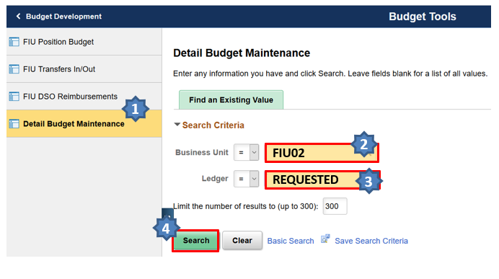
- On the following screen enter Fiscal year = 2024 and the Project ID. To see the ProjectID field you may have to click the View All link. Click the Query link to proceed to the next screen
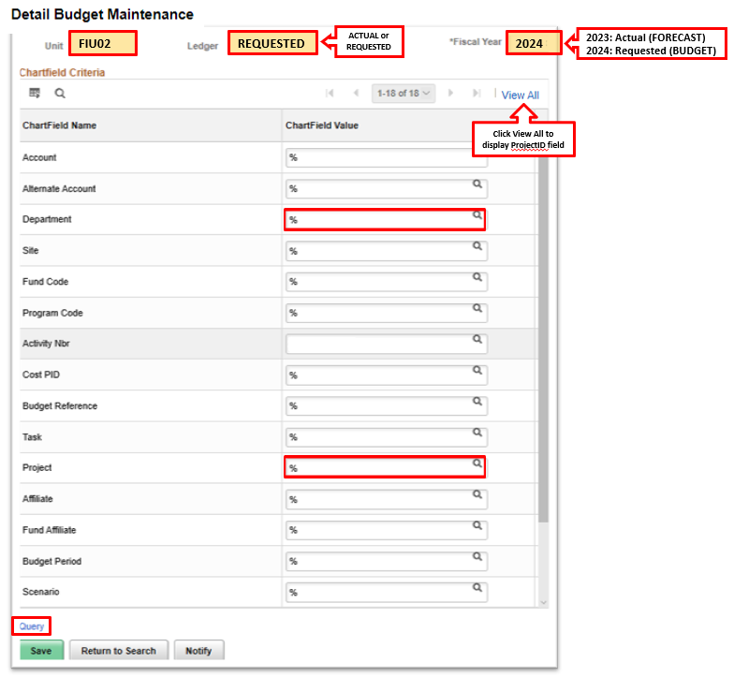

Entering the Budget in REQUESTED Ledger
The Data By Year screen shows all the budgetary accounts used for the various projects under the department ID entered in FY 2023-24.
The Original Budget 2022-23 (Budget Base) and Forecast 2022-23 (Forecast Amount) will also by displayed in the screen, however, any change to Forecast amounts will be made in Ledger ACTUAL (see Section Entering the Forecast in the ACTUAL Ledger page 10). Please note the dollar values in the screen below will be blank until you click the Calculate button.
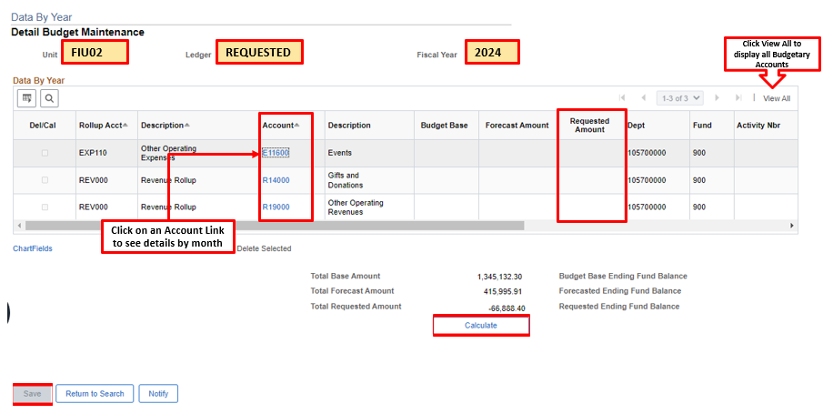
To make changes, click on either the revenue or expense account link as it corresponds to the project for which the change is desired. The following Detail Budget Maintenance (DBM) page will appear:
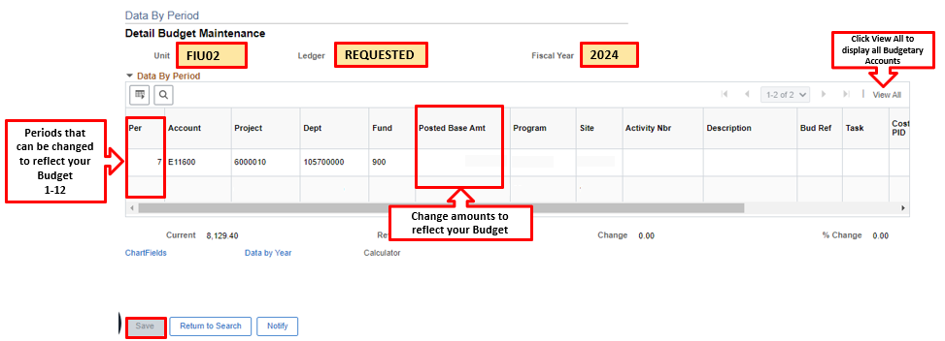
Enter or Edit the following fields as necessary
- Account: (Most often R14000 or E11900)
- Fund: 900 or 903
- Site: (always choose 1 in Actual Ledger for Forecast and 01 in Requested Ledger for Budget)
- Pgm Code: (always use 00)
- Project ID
Click the plus sign “+” in order to add lines for revenues and expenses by period. Once you have the number of lines corresponding to the number of periods in which you expect the revenues or expenses:
- Adjust the period number
- Enter the budget amount for each period
NOTE: The calculator option may also be used to add lines if distributing an amount. See details about Using the Calculator Tool on page 12.
Once you have made all the budget entries for this Project ID, click the Data by Year link or the Save button to go back to the main page and continue with your requested budget for another project.
IMPORTANT:
A budget is required for revenues and expenses for each project in your area including projects that do not yet exist but are expected between now and June 30, 2023.
Use the Project ID number beginning with the first 2 digits associated with your unit and “99999” as the last 5 digits as the project in which to budget revenues and expenses for expected new gifts (e.g. Athletics: Project ID #4099999).

The DSO Reimbursements Tool
Certain expenses such as salary support or scholarships incurred by the university (Business Unit FIU01) are reimbursed by the university Direct Support Organizations (DSOs) such as the FIU Foundation (Business Unit FIU02). This tool allows the users to budget for these reimbursements across Business Units. The user enters the DSO Project ID or Activity Number that will be reimbursing the university with the corresponding Activity Number that will receive the funds as revenue on the university (FIU01) side. The tool will then automatically create the revenue on the university side.
Note: Reimbursements data cannot be changed on the Detail Budget Maintenance (DBM) page - changes to reimbursements transactions can only be made through the DSO Reimbursements Tool.

Creating a DSO Reimbursement
You may only create DSO reimbursement budget transactions for your Project ID or Activity Number.
Allocations are run hourly to copy the values from the DSO Reimbursements Tool to the Detail Budget Maintenance (DBM) page.
Note: In this example, we will use a Foundation (FIU02) Project ID
- Login in to PantherSoft Financials and navigate to the Detail Budget Maintenance (DBM) using the drop-down menu. Select Budget Development and click on Budget Tools Icon. Choose FIU DSO Reimbursements.
- Verify the following Required Fields:
- Business Unit enter corresponding DSO Business Unit, e.g. FIU02
- Ledger field enter:
- ACTUAL for Forecast FY 2022-23
- REQUESTED for Budget FY 2023-24
- Activity Nbr or Project ID, enter your 10-digit Activity Number initiating the reimbursement or 7-digit Project ID. Keep in mind that if you enter a Project ID you will need to choose a Fund Code.
- Fiscal Year
  - 2023 for Forecast FY 2022-23
  - 2024 for Requested Budget FY 2023-24
- Fund Code, for FIU02 ONLY, if a Project ID was entered. Select fund code 900 or 901 depending on the funding source; all other business units will not have to populate a fund code.
- Account, enter the account the reimbursement should be budgeted under in the DSO.
E57008 – Postage
E57010 – Insurance
E57011 – Rental
E57012 – Repairs & Maintenance
E57013 – Professional Services
E57014 – Advertising and Promotion
E57015 – Materials & Supplies
E57000 – All Other Expenses
E57001 – Equipment Expenses
E57002 – Scholarship Expenses
E57003 – Construction Expenses
E57004 – Salary Expenses
E57006 – Events
E57007 – Subscriptions and Memberships

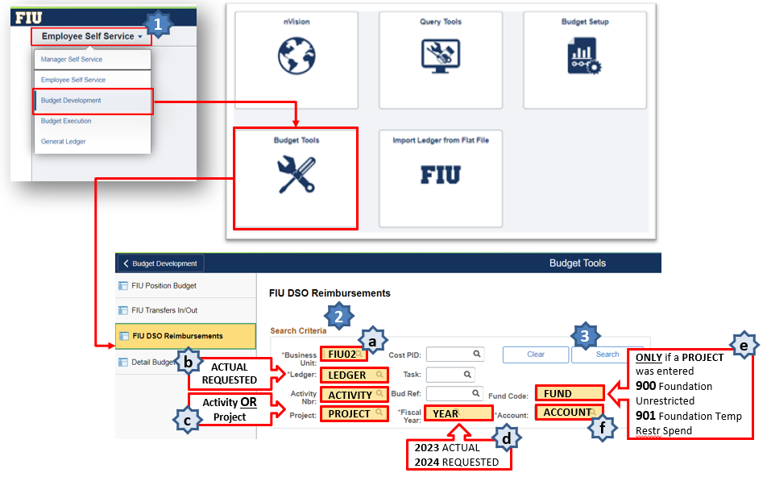
- Click the Search button
Note: From this point onward only information regarding those FIU01 fields receiving the funds are required and can be entered in the tool. (Reimbursements To)
- Enter the FIU01 activity Nbr that will receive the reimbursement in the To Activity Nbr field.
- Enter the revenue budget account that corresponds to this reimbursement (the most frequently used account is R89090 - DSO Revenue).
To search for an Account, click the magnifying glass icon to the right of the Account field and choose from the list of allowable accounts.
To search for an Activity Nbr, click the magnifying glass icon to the right of the Activity Nbr field and choose from the list of activity Numbers.
- Enter the accounting period, i.e. month in which the reimbursement will occur. For your Forecast the available periods are from March to June (9 to 12) for your Requested Budget the available periods are from July to June (1 to 12).
- Enter the amount that the activity Nbr will be receiving as a positive number.
To add additional budgeted reimbursement lines, click the plus sign “+” button; to remove lines, click the minus sign “-“ button.
- Click the Calculate Totals button.
Note: After clicking on “Calculate Totals” OR “Save” the “Transfers from” section will summarize the DSO reimbursements by period and account as shown below.
- Click the SAVE button.
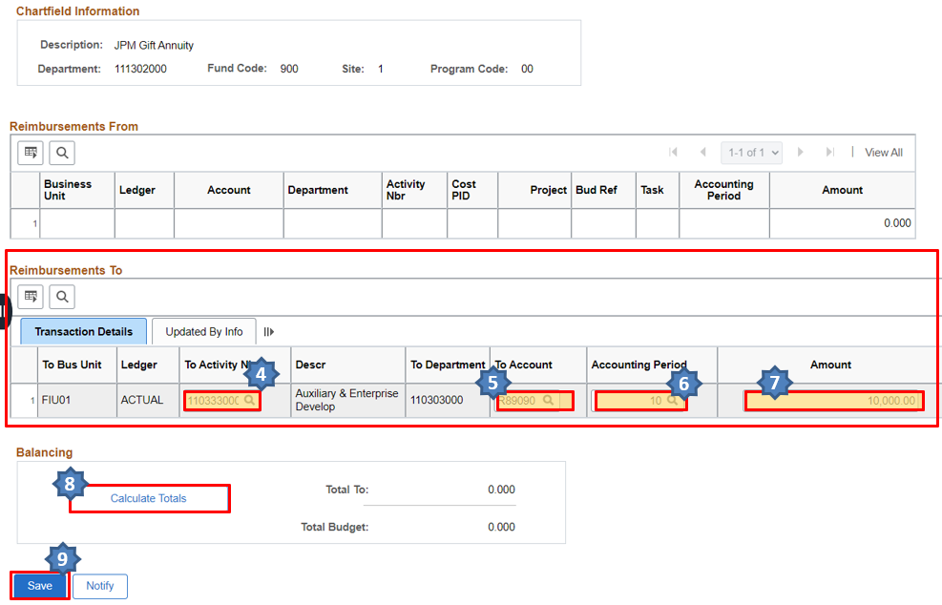

Modifying DSO Reimbursements
- Login in to PantherSoft Financials and navigate to the Detail Budget Maintenance (DBM) using the drop-down menu. Select Budget Development and click on Budget Tools Icon. Choose FIU DSO Reimbursements.
- Verify the following Required Fields:
- Business Unit enter corresponding DSO Business Unit, e.g. FIU02
- Ledger field enter:
- ACTUAL for Forecast FY 2022-23
- REQUESTED for Budget FY 2023-24
- Activity Nbr or Project ID, enter your 10-digit Activity Number initiating the reimbursement or 7-digit Project ID. Keep in mind that if you enter a Project ID you will need to choose a Fund Code.
- Fiscal Year
  - 2023 for Forecast FY 2022-23
  - 2024 for Requested Budget FY 2023-24
- Fund Code, for FIU02 ONLY, if a Project ID was entered. Select fund code 900 or 901 depending on the funding source; all other business units will not have to populate a fund code.
- Account, enter the account the reimbursement should be budgeted under in the DSO.
- Click the Search button
If there are no existing budgeted reimbursements, you will not see any transaction in both “Transfer From” and “Transfer To” sections.
- Enter changes to the existing budgeted reimbursements as necessary
- Click the Calculate Totals button to recalculate
- Click the SAVE button

Running Budget Reports
FIU Foundation budget managers can review their entries to the ACTUAL ledger for Forecast FY 2022-23 and to REQUESTED ledger for the Budget FY 2023-24 through one of two ways:
- Query: FIU02_BUDGET_DATA
- Nvision report: FIU02_BUDGET_BX_BY_PROJECT

FIU02_Budget_Data Query
- Log onto the PantherSoft Reporting Database and go to Query Viewer.
- In the begins with box, enter FIU02 and then click on Search. You will see the query titled FIU02_BUDGET_DATA and search.
- Run the query:
- Click the HTML link to run the query and View Results on the screen. You can download the results to an Excel Spreadsheet, a CSV Text File or XML File.
- Or click the Excel Spreadsheet link to download the results in an Excel Spreadsheet and manipulate the data using the Pivot Table feature.
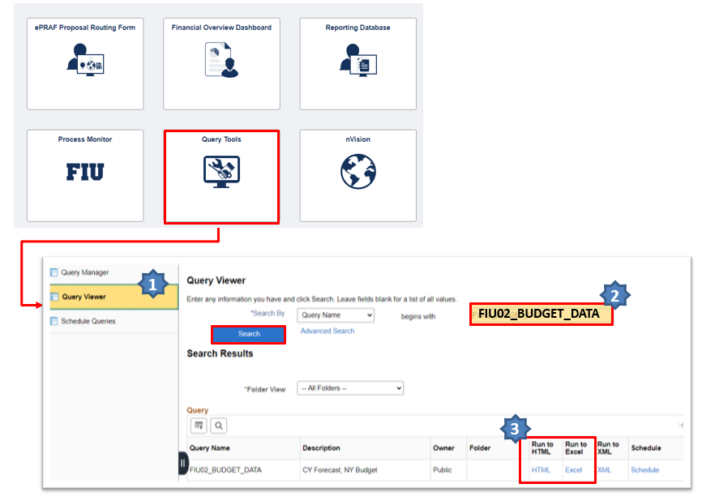
- In the new window type the Department ID or the Project you are looking for and click View Results
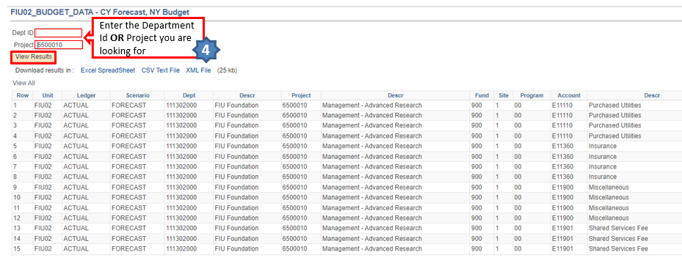

FIU02_Budget_BX_By_Project nVision Report
Log onto the PantherSoft Reporting Database and go to Define Report Request under Reporting Tools/PSnVision. In the Business Unit enter FIU02 for FIU Foundation and click Search button. Select report layout titled: FIU02_BUDGET_BX_BY_PROJECT.
- Log onto the PantherSoft Reporting Database and go to nVision, and choose PS/nVision Schedule Requests
- In the Business Unit field type FIU02
- In the Description field type FIU02_BUDGET_BX_BY_PROJECT and search
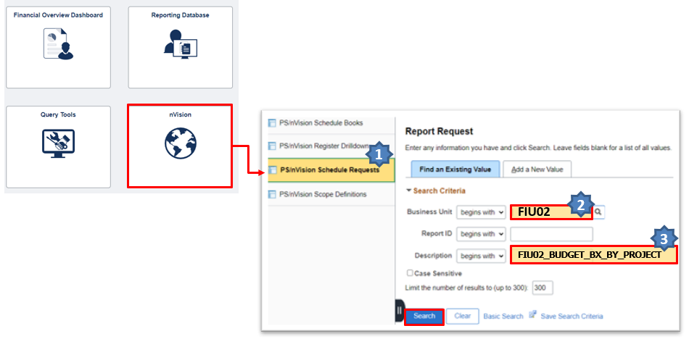
In the new window, verify the following required information:
- Make sure the Layout field is FIU02_BUDGET_BX_BY_PROJECT
- In the As of Reporting Date dropdown menu, type the last day of the current fiscal year: 06/30/2023.
- Choose Web in the field Type.
- Click on the Scope and Delivery Templates link to enter your scope. You may enter the name of your college/school/unit OR any individual Project ID. Click OK
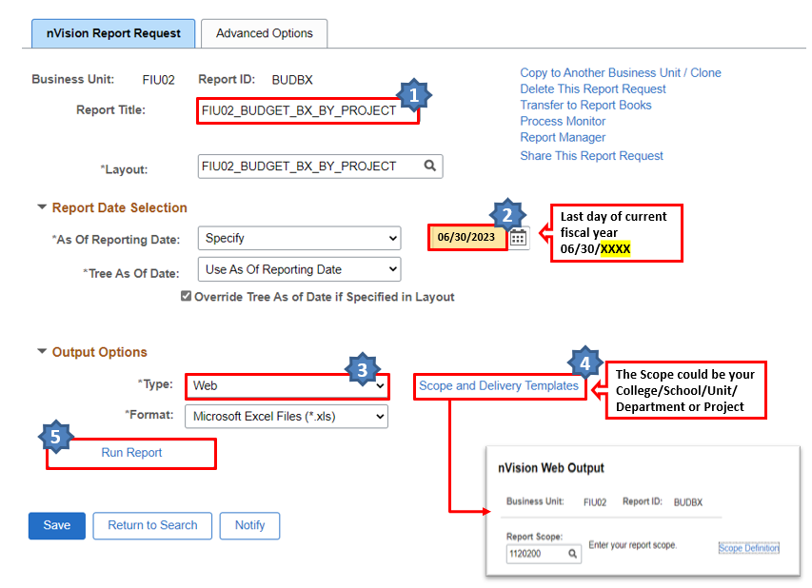
- Click the Run Report button. The Process Scheduler Request window will pop up, click the OK button – there is no longer a need to select a server.
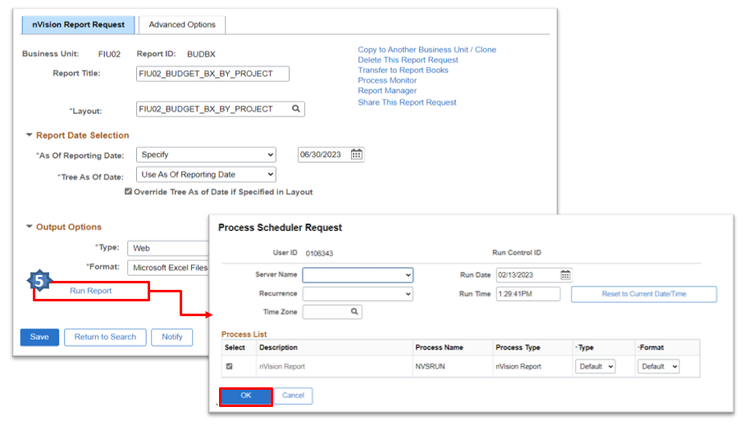
To open the FIU02_BUDGET_BX_BY_PROJECT report
1. Click the Report Manager hyperlink.
2. Click on the Administration Tab to see a list of your reports.
3. Click on the hyperlink of the report you just ran to download it to Excel.
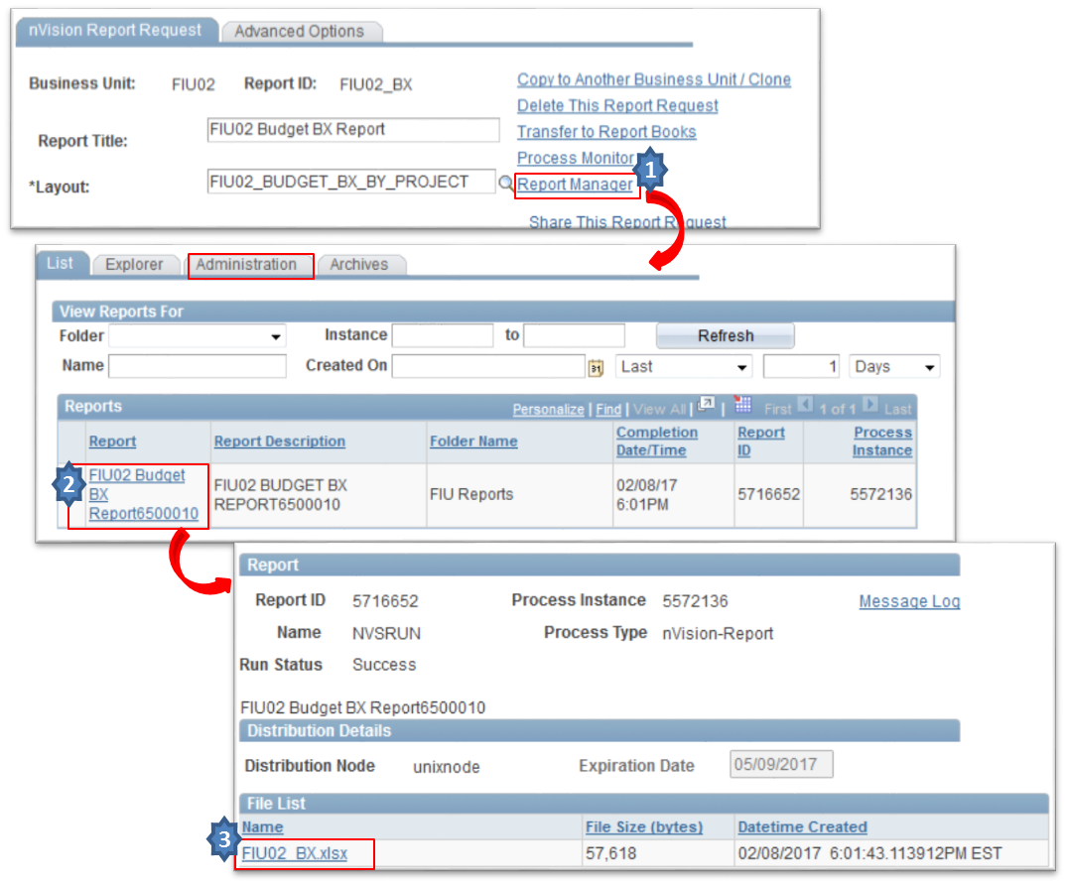
This report contains the following information: Current Year-to-Date Actuals, Forecast 2022-23, Original Budget 2022-23, and Requested Budget 2023-24 (imploded by period for each category).
IMPORTANT: The data in the Reporting database is refreshed overnight and is therefore always one day old. Any changes you make in the ACTUAL and REQUESTED ledgers will not be reflected in your query/report until the next day.

Running Reports After Allocation for 3% Gift Fee Runs
The allocation for the 3% gift fee will run daily from 7:15pm – 8:00pm. Please do NOT run reports or queries or enter data into the budget tool during this brief 45-minute period each day. In order to have the final net revenue amounts for both your current year forecast and next year’s budget, you will need to run the query or BX nVision report the day after your final entries are made into the budget tool.

Deadlines
Deliverable | Due Date
4-Month FY 2022-23 Forecast in ACTUAL Ledger | Friday, March 24, 2023
12-Month FY 2023-24 Budget for Colleges, Schools, Divisions in REQUESTED Ledger. Also due: Building Funds (done by Foundation) | Friday, April 21, 2023
Budget materials presented to upper management and Board leadership | May 15-19, 2023
Budget materials distributed to BOD | Friday, June 2, 2023
BOD Finance meeting (to approve budget) | Friday, June 9, 2023
Annual Board of Directors meeting (to approve budget) | Saturday, June 10, 2023
BOT Finance & Facilities Committee meeting (to approve budget) | Thursday, June 15, 2023

Post-Budget Accountability
The FIU Foundation Board of Directors receives monthly financial recaps and requests explanations for each significant variance between budget and actuals (for both revenues & expenses).
Budget managers are responsible for submitting monthly variances to the Foundation for presentation to BOD in a timely manner each month.
STEP 1: Run Budget vs. Actuals nVision Report
STEP 2: Determine which projects carry significant variances
STEP 3: Compare YTD actuals to YTD budget and determine cause:
- Positive Revenue Variance – new gift not included in budget?
- Negative Revenue Variance – gift included in budget will not be received?
- Positive Expense Variance – savings, delays?
- Negative Expense Variance – Why?
STEP 4: Be specific in explanation: Ask the questions….. What? When? Why?
The following PantherSoft reports are available to run online:
- Budget vs. Actuals (to be run with scopes for individual project or entire unit) - FIU02_BUDGET_VS_ACTUALS
- Actuals by Project - FIU02_ACTUALS_BY_PROJ2

Questions & Support
For any questions or support during the budget process, please contact:
Milly Garcia Chica, CPA
Assistant Vice President
FIU Foundation, Inc.
Telephone: 305-348-8377
Email: garciami@fiu.edu

Appendix – Looking Up Budgetary Accounts
You can look up Budgetary Accounts in the PantherSoft Financials system using the Tree Viewer or the Query Viewer, as describe below:

Looking Up Budgetary Accounts Using Tree Viewer
- Navigate to the Tree Viewer page using the drop-down menu Budget Execution
- Select Tree Viewer
- Search by Tree Name and in the “begins with” input area look for MGMT_RPT_ACCTS
- Click on Search Button.
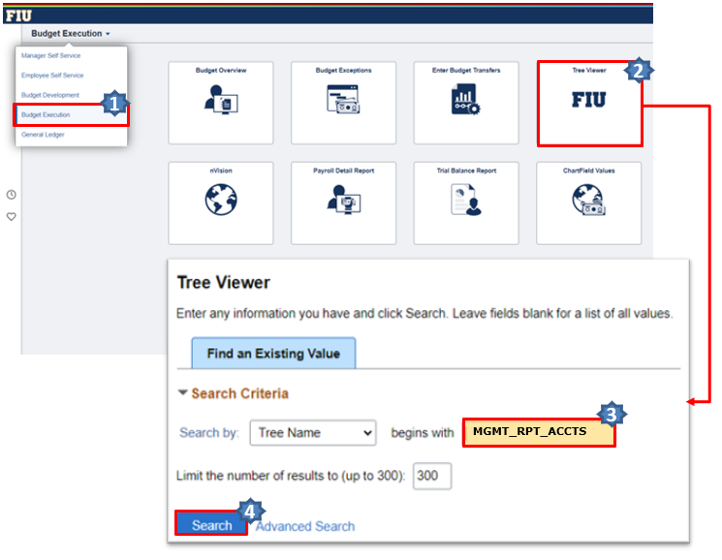
- Select Find
- If you are looking for the GL Accounts that roll-up into a budgetary account, enter the budgetary account in the Find Tree Node field. (Note: revenue accounts start with “R”, and expense accounts start with “E”)
- If you are looking for the budgetary account into what a specific GL Account roll-ups, enter the GL account in the Find Detail Value field. (Note: revenue accounts start with “6”, and expense accounts start with “7”)
- Select Find
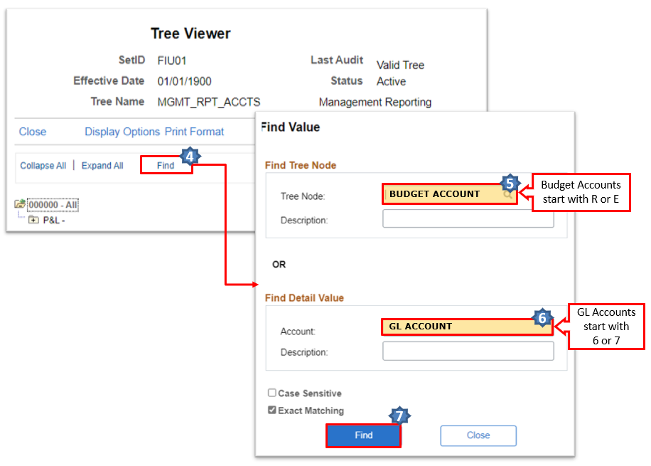
- The view will return the map displaying the account or account range. Use the Tree Node field If you need to find the GL accounts:
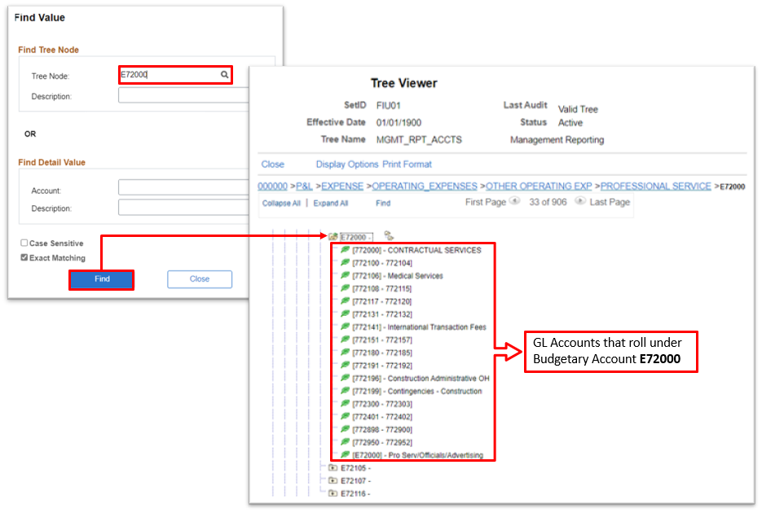
If you need to find the budgetary account:
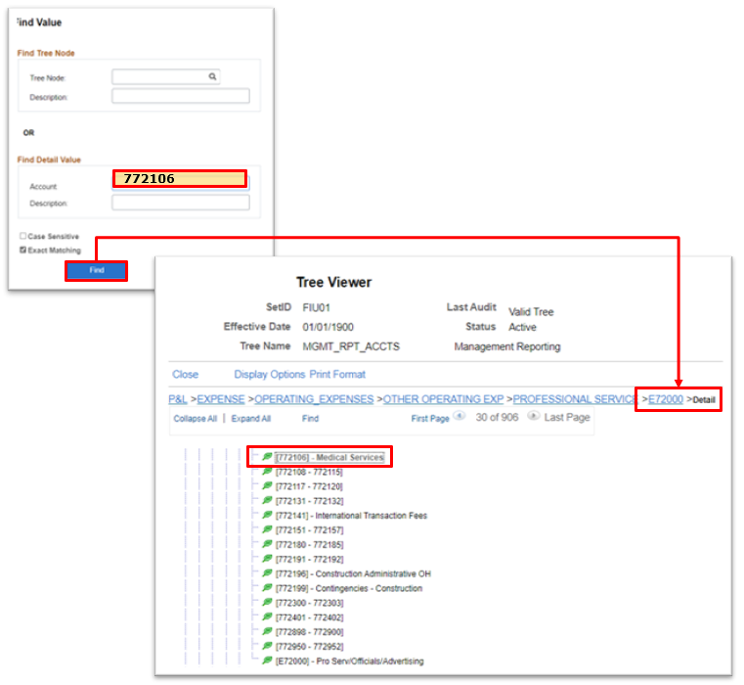

Looking Up Budgetary Accounts Using Query Viewer
- Navigate to the Reporting Tools page using the drop-down menu Budget Execution
- From Query Viewer or Query Manager, search by “Query Name” and enter “FIU_BUDGET_ACCOUNTS” in the “begins with” Combo Box.
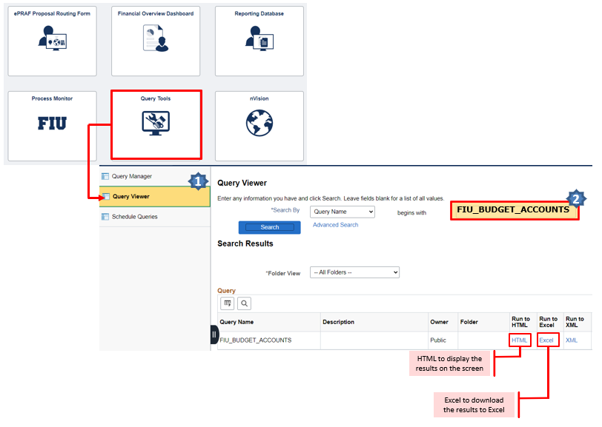
After entering the query and selecting the Excel format, an .xls file will be generated with all budgetary revenue and expense accounts and their corresponding actual accounts.

