A FIU Foundation Project (7digit number in PeopleSoft) must be created to track donations received and expenses that are allowed as per the donor’s documented intent.

Refer to the following related policies found on the Foundation website for requirements:
- Minimum Required to Establish Accounts Policy
- Establishing Endowment Accounts Policy

In order to request a project, please complete the form in the following link:
- New Foundation Project Request Form
Once the form has been approved by the department budget org approvers via the e-form, it will route to Foundation Business Office for review and approval. Once Foundation has approved, an e-mail will be sent to all parties notifying the project has been set up by Foundation.

The Foundation New Project Request Form is located on the FIU Foundation website under the Online Forms tab.

Project Description Form

Refer to the instructions on how to complete a new foundation project request form.
The instructions can be found on the online form: New Foundation Project Request Form
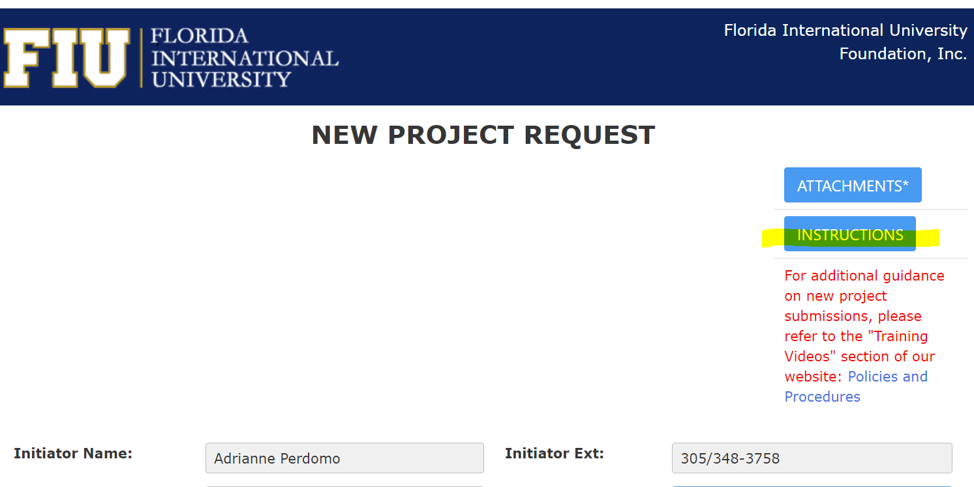

Please note that all supporting documentation must be attached to the New Project Request Form.

Note for “BUILDING FUNDS” type projects: These projects should be listed under the BUILDING FUNDS range in the balance sheet. All BUILDING FUNDS projects should start with a “5”. All Building Fund Projects are centrally managed by the Foundation, therefore should always have the central org department number assigned to the project. The central org department number assigned should be 111302000 - FIU Foundation.

Below is a print screen of the BUILDING FUNDS project listing for Foundation (as of 3/3/2021):

